**Week 2**

**(man, manu = hand)**

Emancipate (v)—to set free; to lend a hand in freeing someone; to release from someone’s **hands**

Manacles (n)—**handcuffs**

Manager (n)—a person who has the upper **hand;** a person who is in charge of someone or something

Mandate (n)—an order or command placed in one’s **hands**

Maneuver (v)—to **handily** or skillfully go around something

Manicure (n)—a treatment for the **hands** and nails

Manipulate (v)—to skillfully operate by **hand**

Manual (n)—a **handbook;** a book of directions

Manufacture (v)—to make by **hand** or by machine; to change raw material into a new product

Manuscript (n)—a **handwritten** or typed piece of writing, such as a book

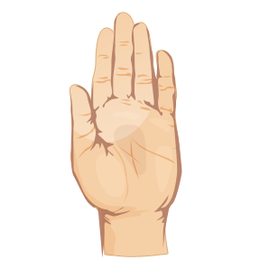  C:\Users\owner\AppData\Local\Microsoft\Windows\Temporary Internet Files\Content.IE5\7M0Y215S\MC900390722[1].wmf C:\Users\owner\AppData\Local\Microsoft\Windows\Temporary Internet Files\Content.IE5\DED5Q67Z\MC900311310[1].wmf